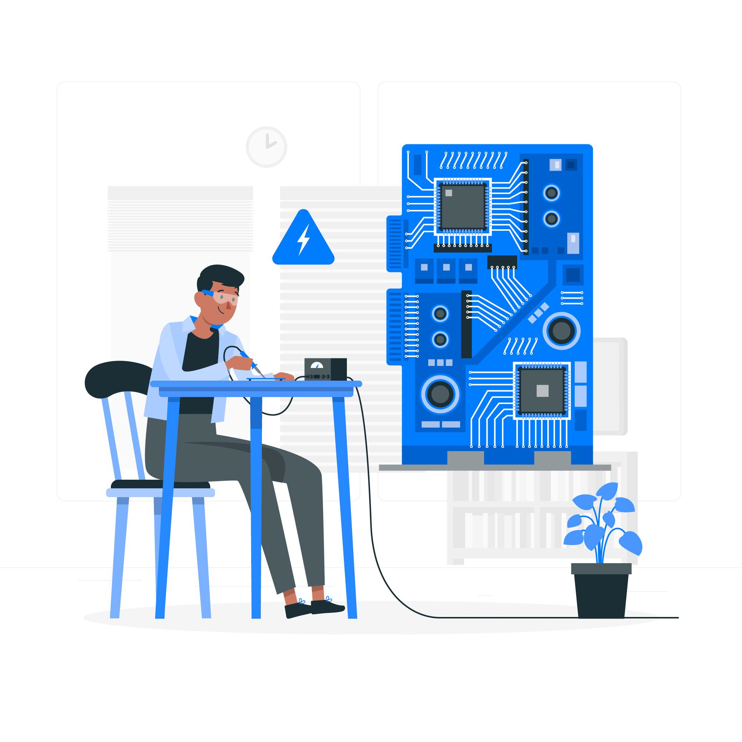

|  |  |
| --- | --- |
|  | Lab 3:Pulse code modulation. |
|  |  |
|  | Akshar panchani- ID 202101522  CT303 Digital Communication  10/8/23 |

**Lab 3: PCM and matlab code**

1. **Tutorial question**

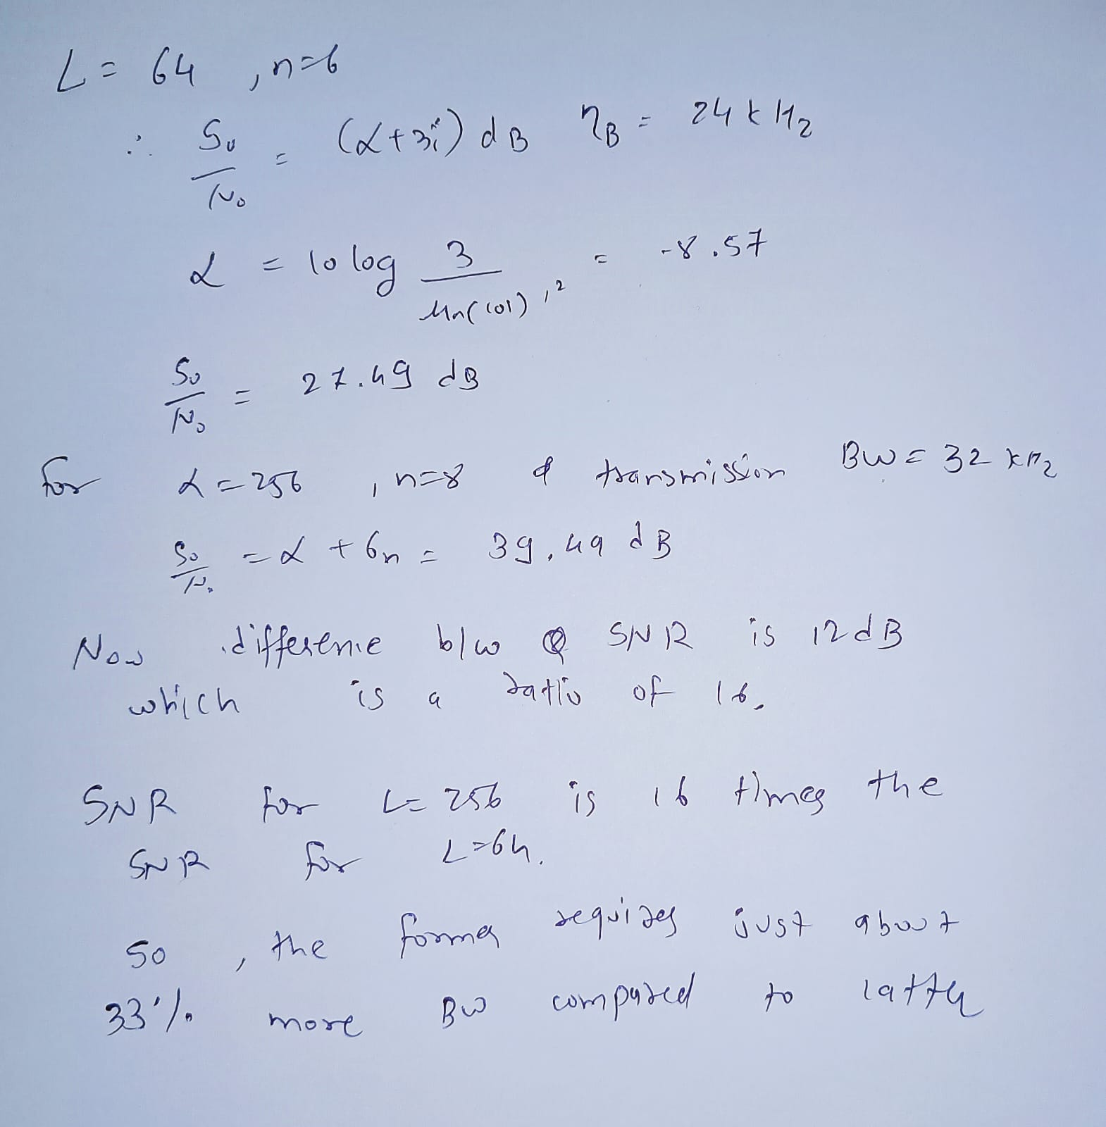

1. **Hardware Experiment**

Experiment 8:

Freq: 500Hz Freq: 1500Hz

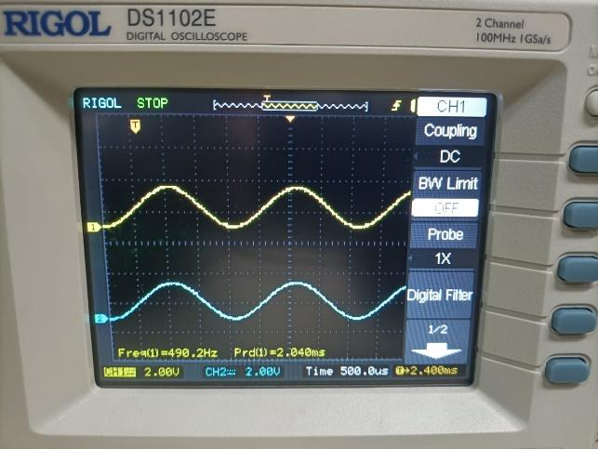 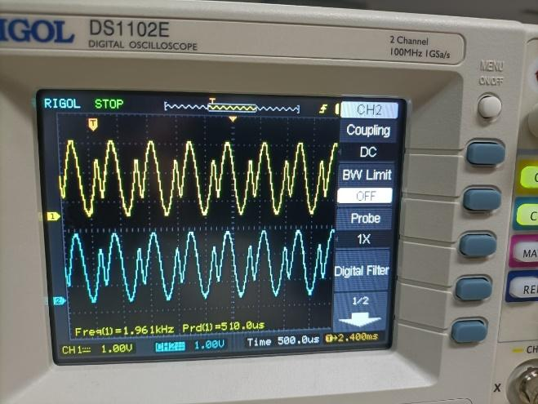

Freq: 500Hz Freq: 500Hz

Sampling freq: 8KHz

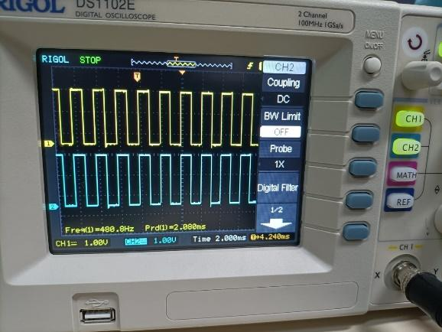 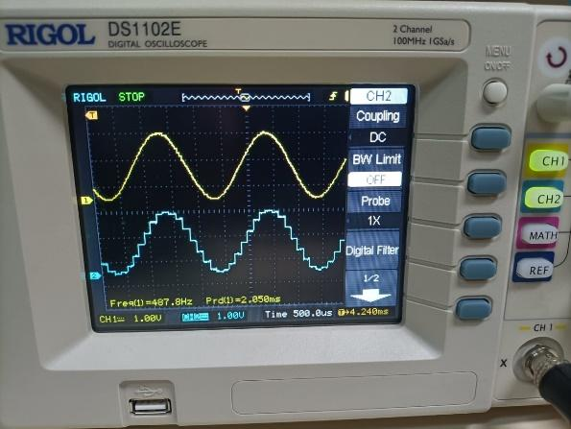

Freq: 500Hz Freq: 1500Hz

Sampling freq: 16 KHz

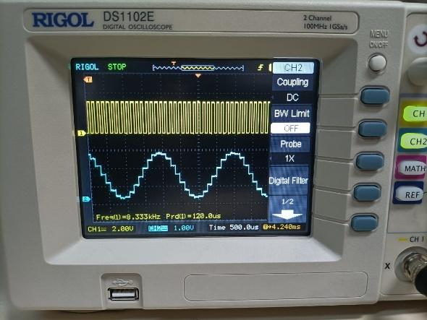 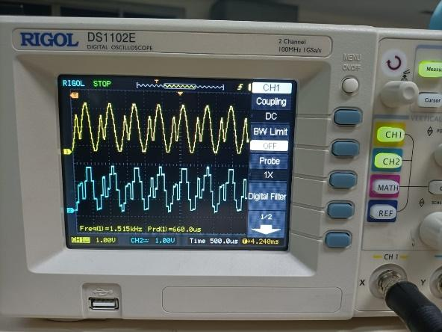

Freq: 500Hz Freq: 1500Hz

Sampling freq: 8 KHz

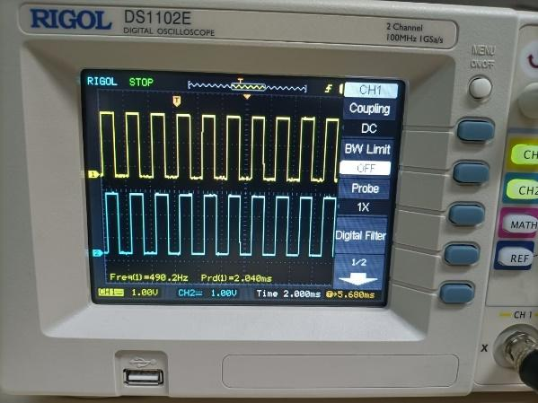 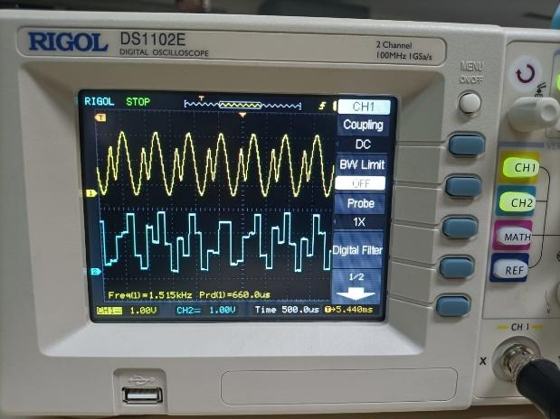

Experiment- 9:

Freq: 500Hz Freq: 500Hz

Sampling freq: 8KHz Sampling freq: 8 KHz

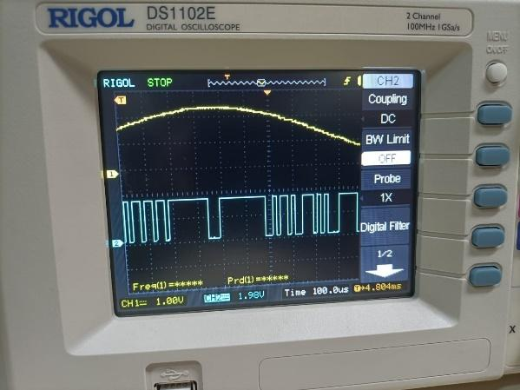 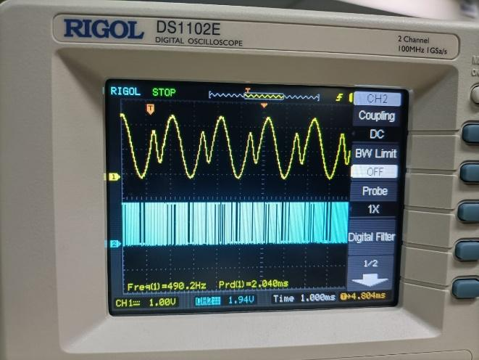

Freq: 500Hz Freq: 1000Hz

Sampling freq: 8KHz Sampling freq: 16 KHz

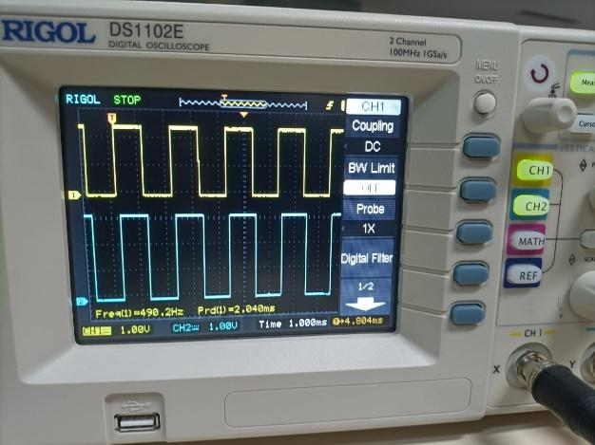 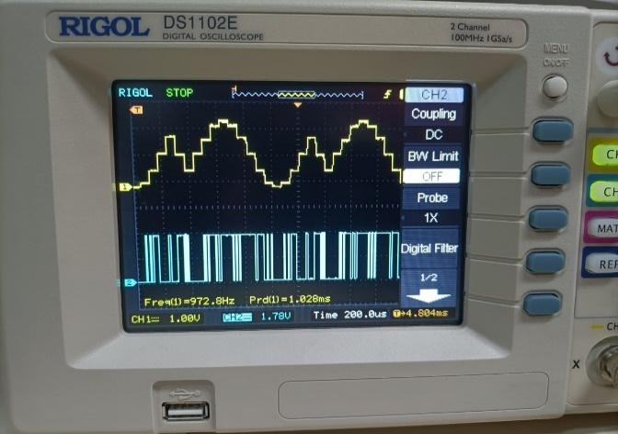

Freq: 500Hz Freq: 1500Hz

Sampling freq: 8KHz Sampling freq: 8 KHz

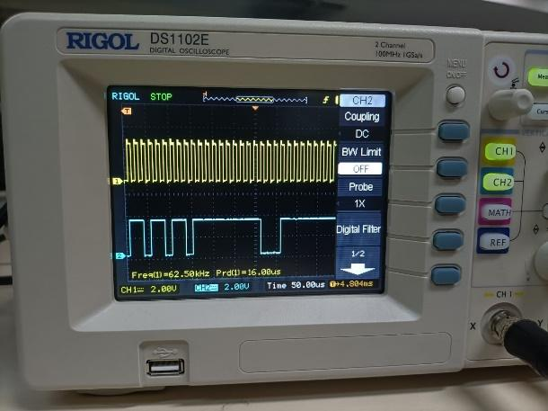 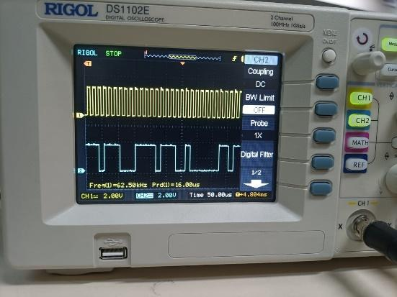

Freq: 500Hz

Sampling freq: 8KHz

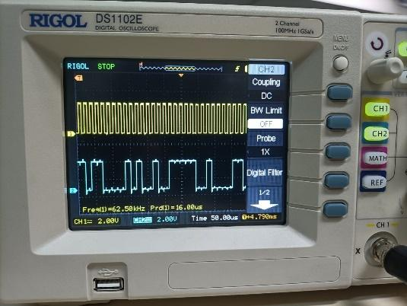

Experiment 10:

Freq: 500Hz Freq: 500Hz

Sampling freq: 8KHz Sampling freq: 16 KHz

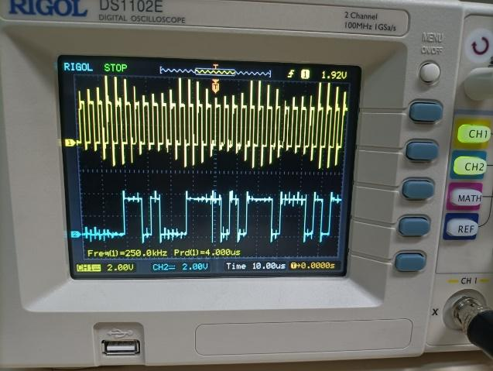 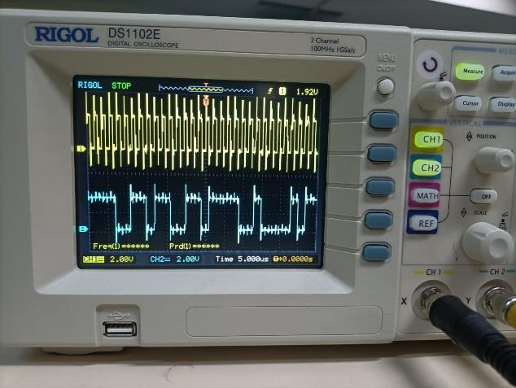

Freq: 500Hz Freq: 500Hz

Sampling freq: 32KHz Sampling freq: 8 KHz

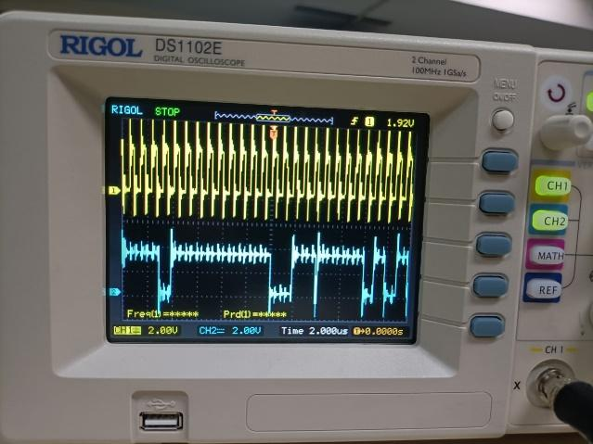 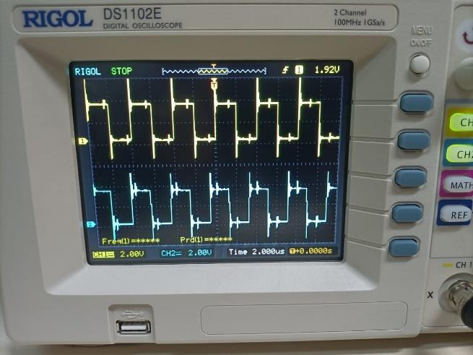

Experiment 11:

Freq: 500Hz Freq: 500Hz

Sampling freq: 8KHz Sampling freq: 16 KHz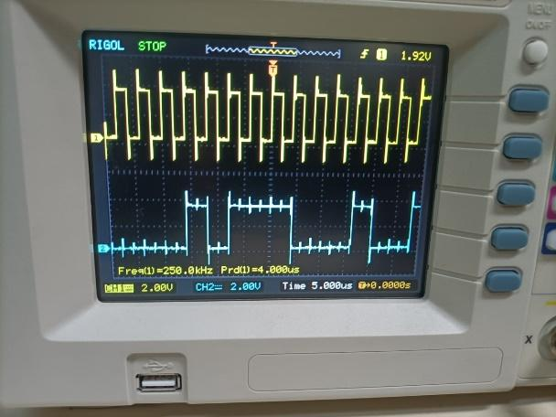 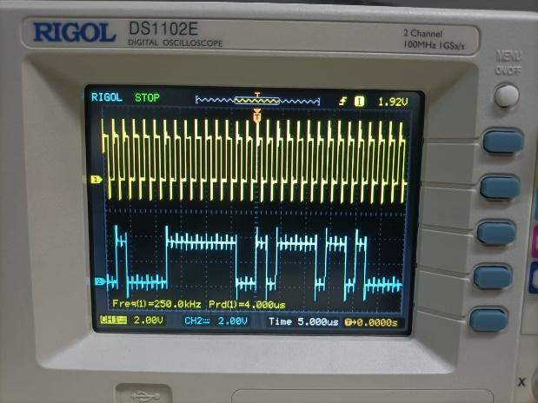

Freq: 500Hz Freq: 500Hz

Sampling freq: 32 KHz Sampling freq: 8 KHz

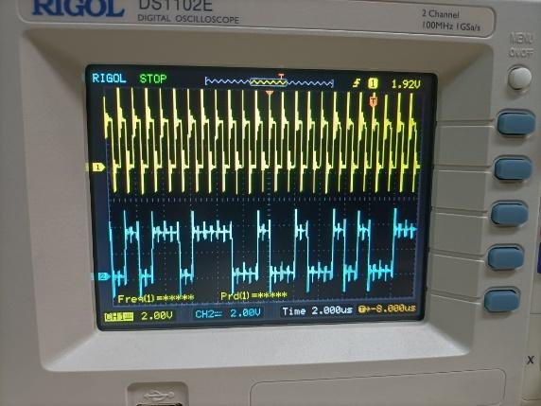 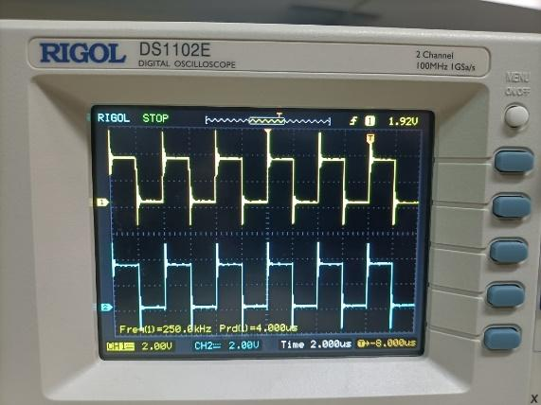

Freq: 500Hz

Sampling freq: 8 KHz

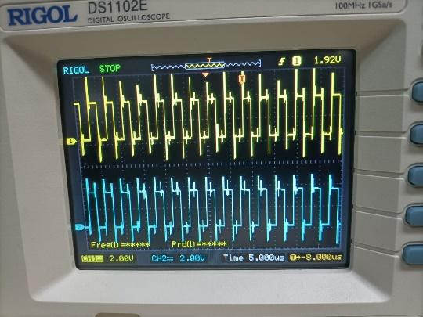

Experiment 12:

Freq: 500Hz Freq: 500Hz

Sampling freq: 8 KHz Sampling freq: 8 KHz

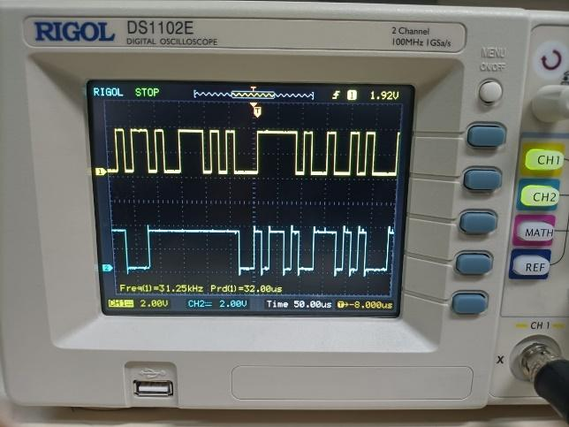 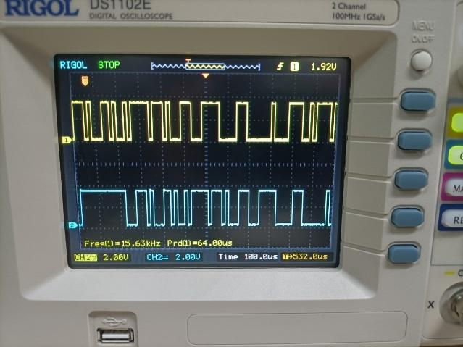

Freq: 500Hz

Sampling freq: 8 KHz

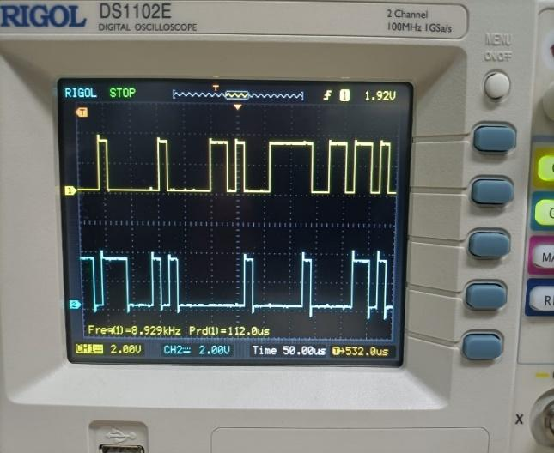

Experiment 13:

Freq: 500Hz Freq: 500Hz

Sampling freq: 8 KHz Sampling freq: 8 KHz

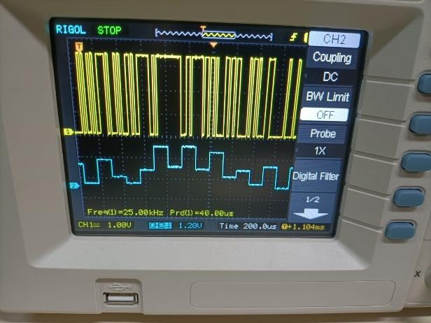 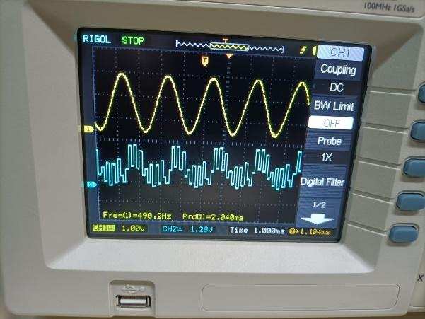

Freq: 500Hz Freq: 500Hz

Sampling freq: 8 KHz Sampling freq: 8 KHz

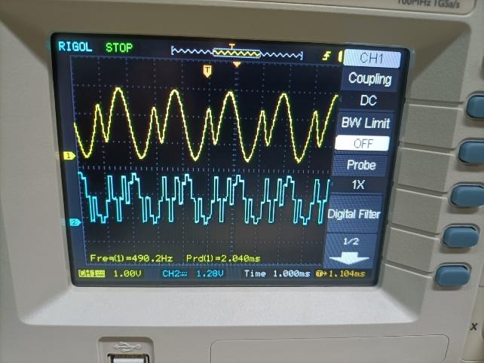 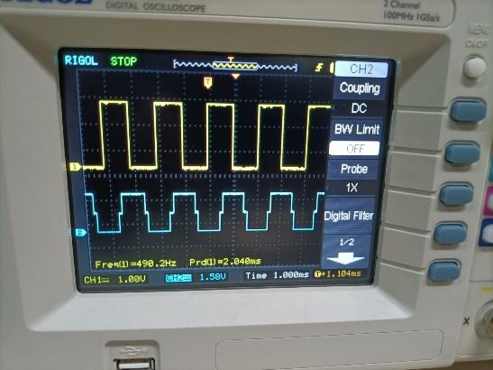

Freq: 500Hz

Sampling freq: 8 KHz

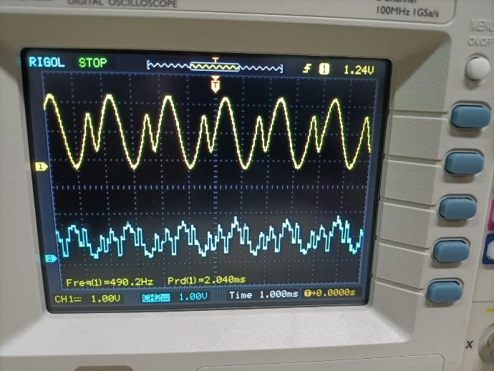

Experiment 14:

Freq: 500Hz Freq: 1500Hz

Sampling freq: 8 KHz Sampling freq: 8 KHz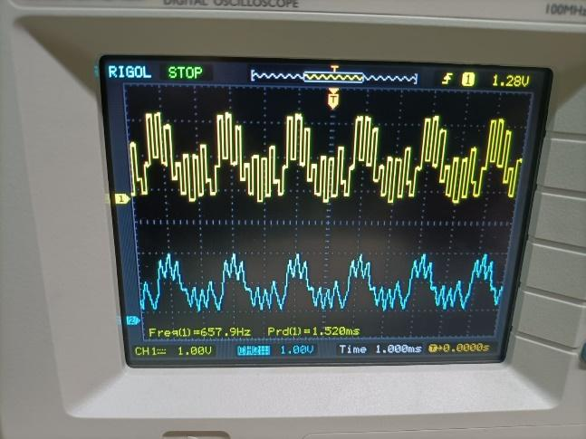 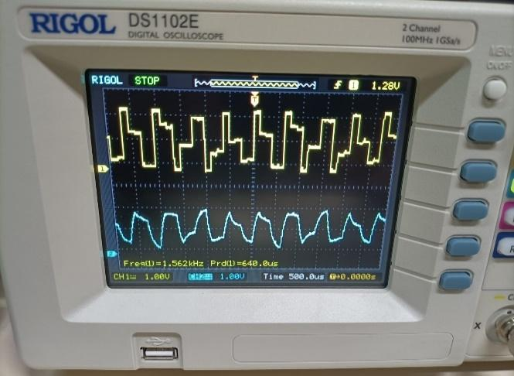

Freq: 1500Hz Freq: 1500Hz

Sampling freq: 8 KHz Sampling freq: 16 KHz

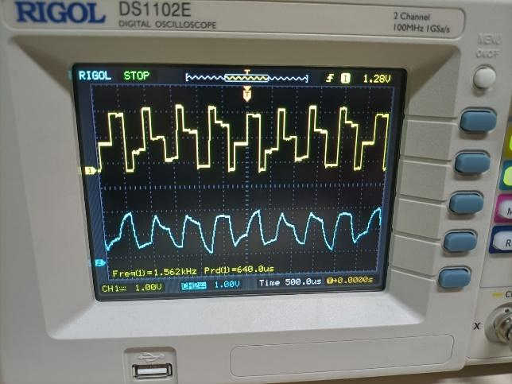 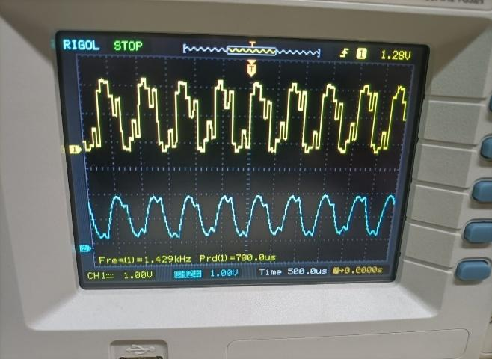

Freq: 500Hz Freq: 1500Hz

Sampling freq: 8 KHz Sampling freq: 8 KHz

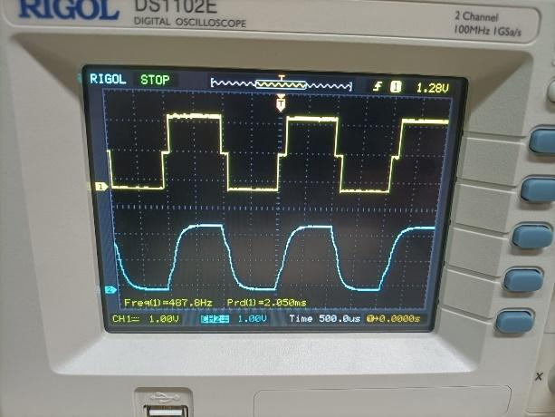 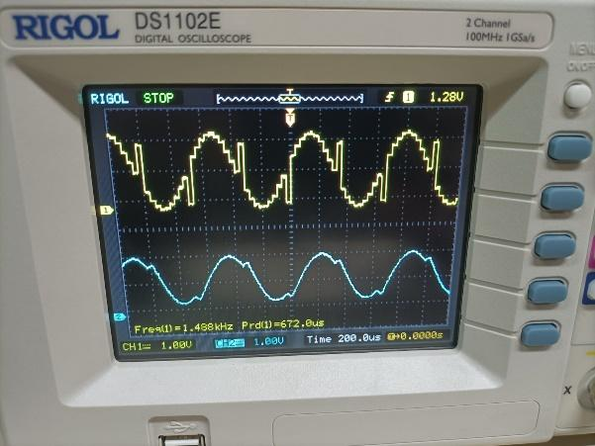

Freq: 500Hz Freq: 500Hz

Sampling freq: 8 KHz Sampling freq: 8 KHz

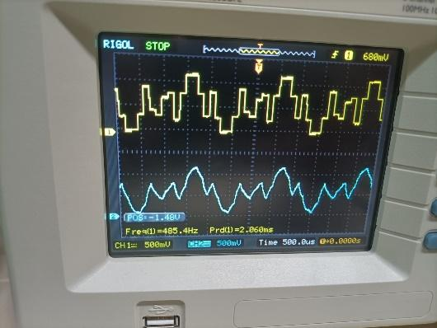 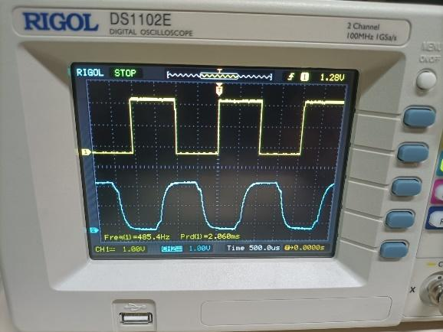

Freq: 1000Hz Freq: 1500Hz

Sampling freq: 8 KHz Sampling freq: 8 KHz

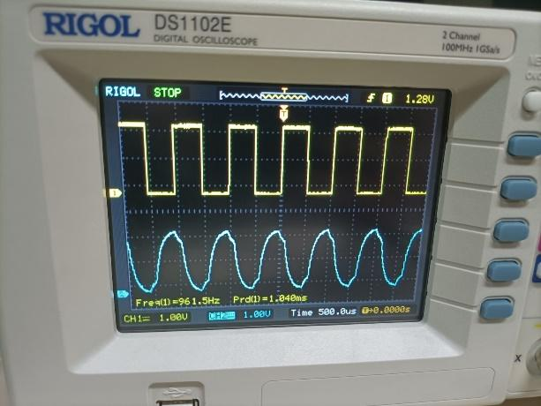 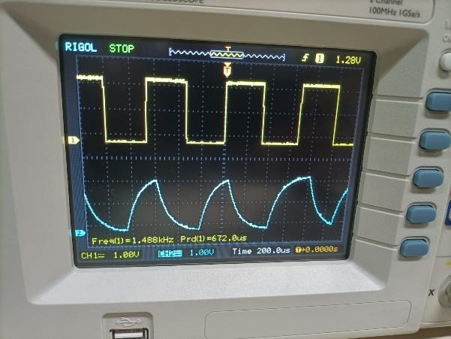

Freq: 2000Hz Freq: 3000Hz

Sampling freq: 8 KHz Sampling freq: 8 KHz

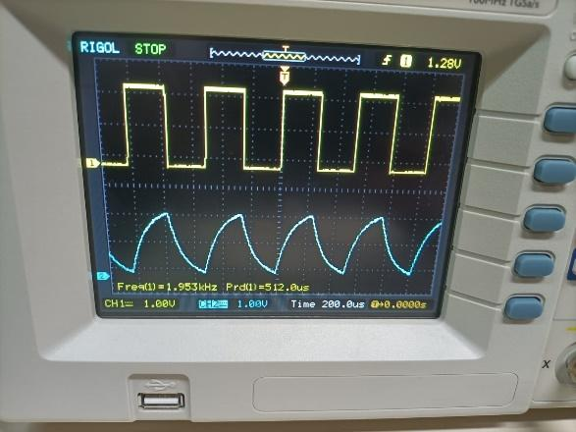 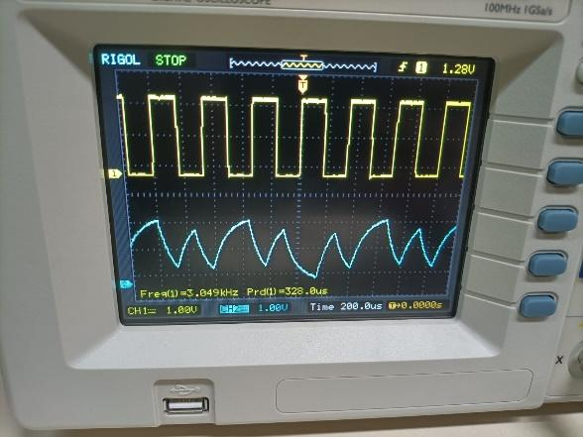

1. **Matlab**

|  |
| --- |
| **% generating a rectangular pulse of width T/2**  **function pout=prz(T)**  **pout=[zeros(1,T/4) ones(1,T/2) zeros(1,T/4) ];**  **end** |
| **% generating a sinusoidal pulse of width T**  **function pout=psine(T)**  **pout=sin(pi*(0:T-1)/T) ;**  **end** |

|  |
| --- |
| **function y=prcos(rollfac, length, T)**  **y=rcosdesign(rollfac, length, T,'normal' ) ;**  **end** |

|  |
| --- |
| **clear;**  **data = sign ( randn(1, 400 ) );**  **Tau=64 ;**  **dataup=upsample ( data , Tau ) ;**  **yrz=conv ( dataup , prz ( Tau ) );**  **yrz =yrz (1: end-Tau+1 );**  **ynrz =conv( dataup , pnrz ( Tau ) );**  **ynrz =ynrz (1:end-Tau+ 1 ) ;**  **ysine=conv( dataup , psine ( Tau ) );**  **ysine = ysine (1: end-Tau+ 1 ) ;**  **Td=4 ;**  **yrcos=conv ( dataup , prcos (0.5,Td , Tau ) );**  **yrcos = yrcos (2*Td*Tau : end- 2 *Td*Tau+ 1 ) ;**  **eyel=eyediagram( yrz , 2 *Tau , Tau,Tau/ 2 ) ;**  **title ( ' RZ eye-diagram ' );**  **eye2=eyediagram( ynrz , 2 * Tau , Tau , Tau/2 ) ;**  **title ( ' NRZ eye-diagram ' );**  **eye3=eyediagram( ysine , 2*Tau , Tau , Tau/2 ) ;**  **title(' Half-sine eye-diagram ' );**  **eye4=eyediagram( yrcos , 2*Tau,Tau ) ;**  **title ( 'Raised-cosine eye-diagram' );** |

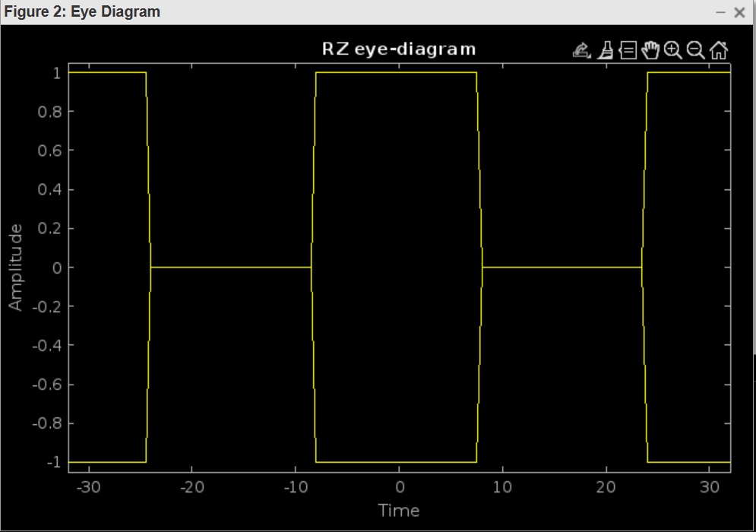

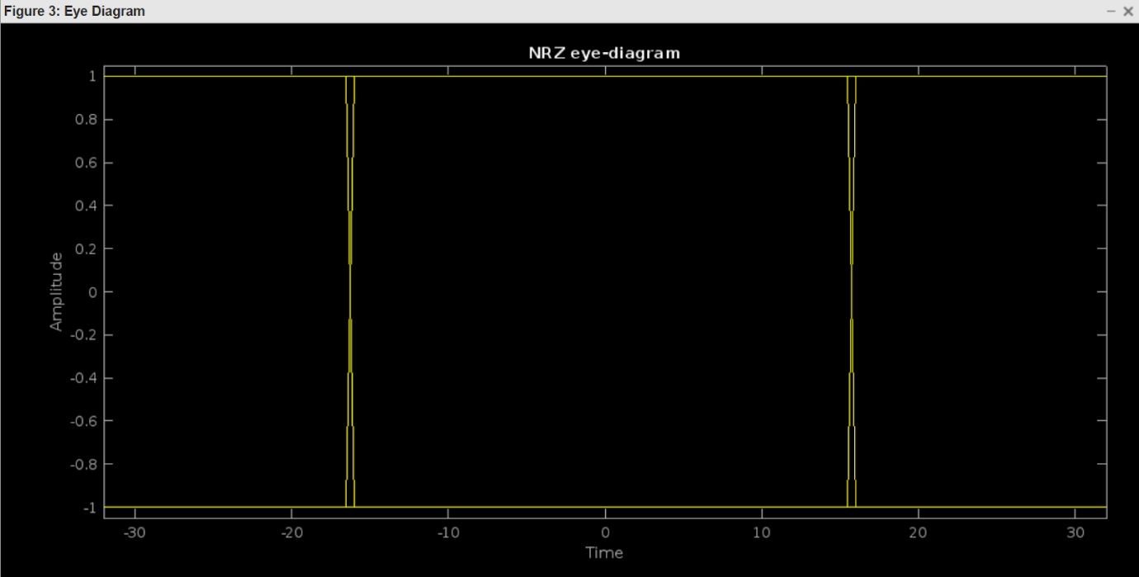

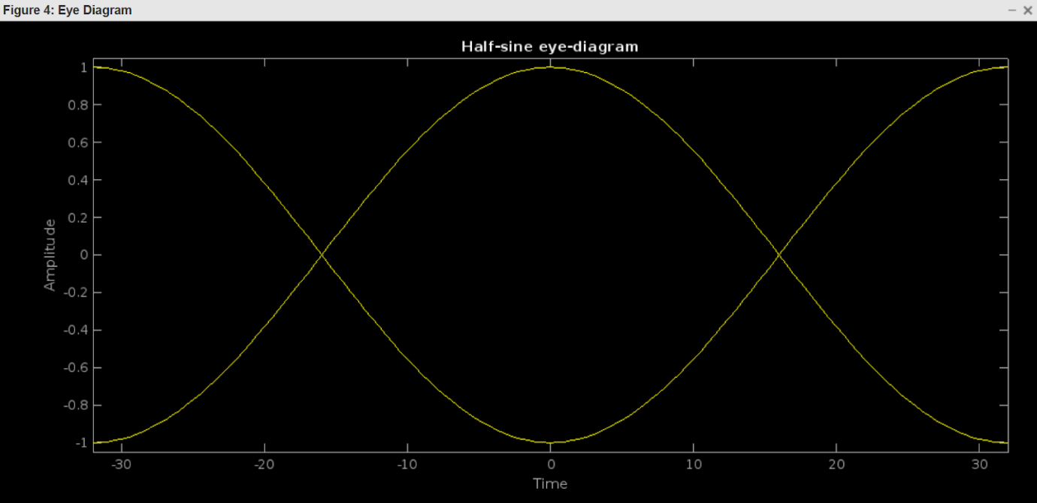

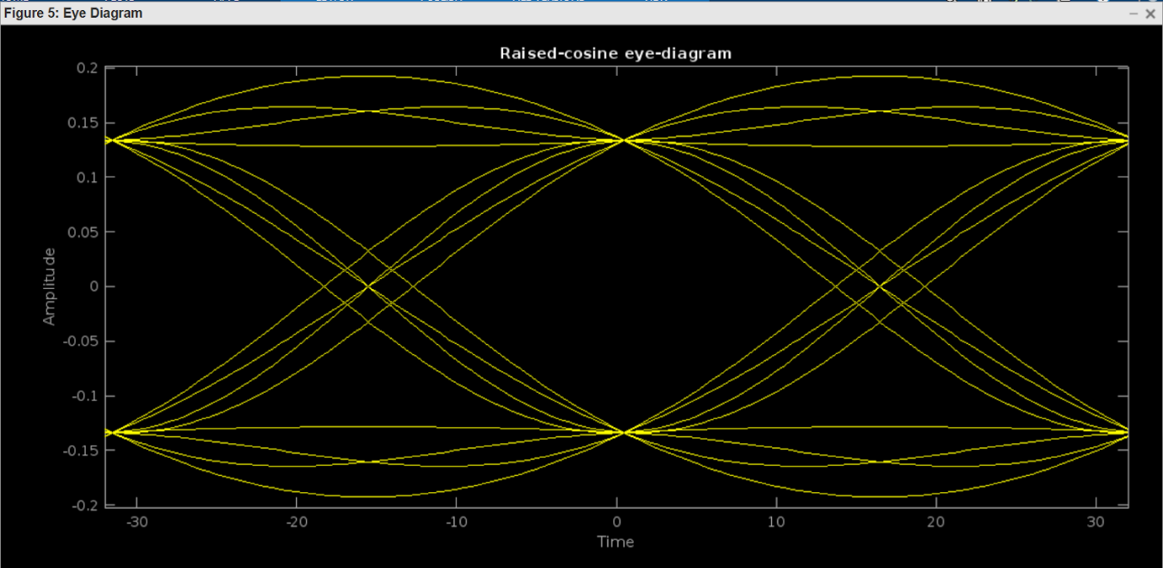

|  |
| --- |
| **Clear all**  **data = sign( randn(1,400) ) + 2* sign ( randn( 1,400) );**  **Tau=64 ;**  **dataup=upsample ( data , Tau ) ;**  **yrz =conv(dataup,prz ( Tau ) );**  **yrz =yrz (1: end-Tau+ 1 ) ;**  **ynrz =conv ( dataup , pnrz ( Tau ) );**  **ynrz =ynrz (1:end-Tau+ 1 ) ;**  **ysine=conv ( dataup , psine ( Tau) );**  **ysine=ysine ( 1 : end-Tau+1 ) ;**  **Td=4 ;**  **yrcos = conv ( dataup , prcos (0.5,Td , Tau ) );**  **yrcos = yrcos( 2 * Td*Tau : end- 2 *Td*Tau+ 1 ) ;**  **eyel = eyediagram(yrz , 2 *Tau , Tau , Tau/2 ) ;**  **title('RZ eye-diagram');**  **eye2 = eyediagram(ynrz , 2 * Tau , Tau , Tau/ 2 ) ;**  **title ( ' NRZ eye-diagram ' );**  **eye3 = eyediagram(ysine , 2 *Tau , Tau , Tau/2 ) ;**  **title ( ' Half-sine eye-diagram ' );**  **eye4=eyediagram ( yrcos , 2 * Tau,Tau );**  **title('Raised- cosine eye -diagram ' );** |

